Kaeser Compressors, Inc.
PO Box 946 Fredericksburg, VA 22404 USA
Phone: (540) 898-5500 us.kaeser.com

Press Contact: Michael Camber • (540) 684-9489
pr.us@kaeser.com

04/11/24
FOR IMMEDIATE RELEASE

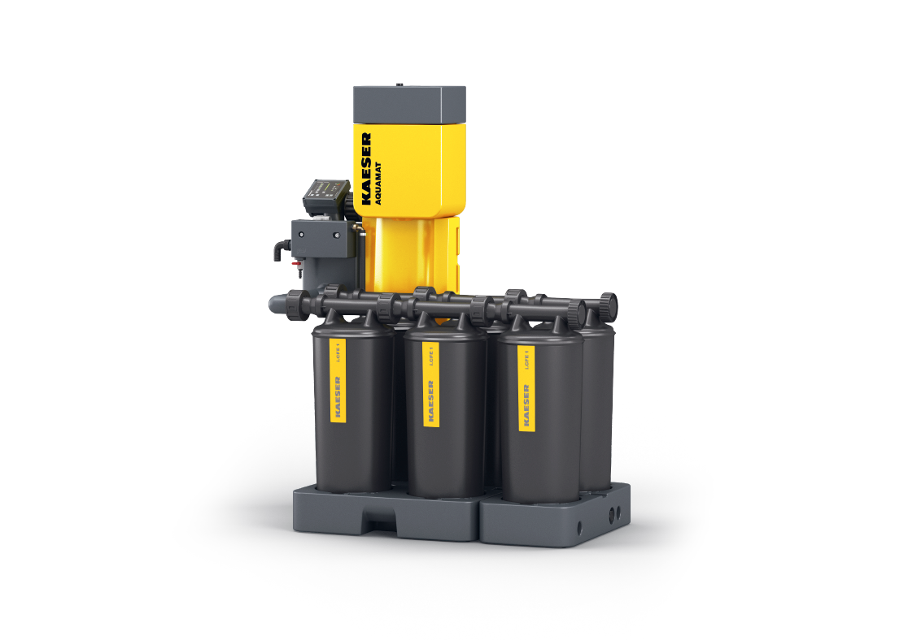 | AQUAMAT i.CF is available in multiple configurations for flow rates from 400 to 3300 scfm.  Download a high-resolution image here.

AQUAMAT i.CF

AQUAMAT i.CF with AQUAMAT CONTROL provides clean and effective condensate separation for flow rates up to 3,300 scfm

Kaeser Compressors, a leading innovator in compressed air system solutions, announces its new oil-water separator, designed to maximize efficiency, simplify maintenance, and seamlessly integrate with modern industrial environments.

Unlike traditional gravity-fed systems, the AQUAMAT i.CF employs an active process using compressed air to more evenly distribute condensate throughout the filter. This innovative approach ensures environmental compliance while maximizing utilization of the filter media for longer service intervals. Ergonomic design and drip-proof cartridges offer fast, no-mess servicing

The separator boasts the new intelligent AQUAMAT CONTROL that tracks cartridge life. Seamless connectivity via Modbus TCP allows real-time monitoring and proactive maintenance, ensuring optimal performance and preventing costly downtime. The controller also sends alerts when service is needed, maximizing cartridge life before replacement.
The AQUAMAT i.CF’s innovative modular design allows customers to easily expand capacity to flows up to 3,300 scfm as their production grows with less capital outlay. Each added module uses the same cartridge, simplifying parts management and reducing service costs.

“Although the oil/water separator is a small part of the compressed air system,” said Justin Aycock, Air Treatment Product Manager, “the new i.CF enhances the entire system by providing a more reliable condensate separation process with better monitoring and servicing functionality.”

For more information, visit us.kaeser.com/icf. To be connected with your local authorized Kaeser representative, please call (877) 417-3527.

###

About Kaeser Compressors, Inc.: Kaeser Compressors is a leader in reliable, energy efficient compressed air equipment and system design. We offer a complete line of superior quality industrial air compressors as well as dryers, filters, SmartPipe™, master controls, and other system accessories. Kaeser also offers blowers, vacuum pumps, and portable gasoline and diesel screw compressors. Our national service network provides installation, rentals, maintenance, repair, and system audits. Kaeser is an ENERGY STAR Partner.

